**Subsector/Population Shapefile**

Defines the subsector polygons and populations, and the node which vehicles will evacuate

from. Must have following description

**Shapefile: hn_evacuationmodel_Y_VXsubsectorsVehicZ**

Where:

Y is the release area (i.e. different file for each release area)

X is version number

Z is development year (i.e. may be a different file for 2026 or 2041 depending on rate of development uptake)

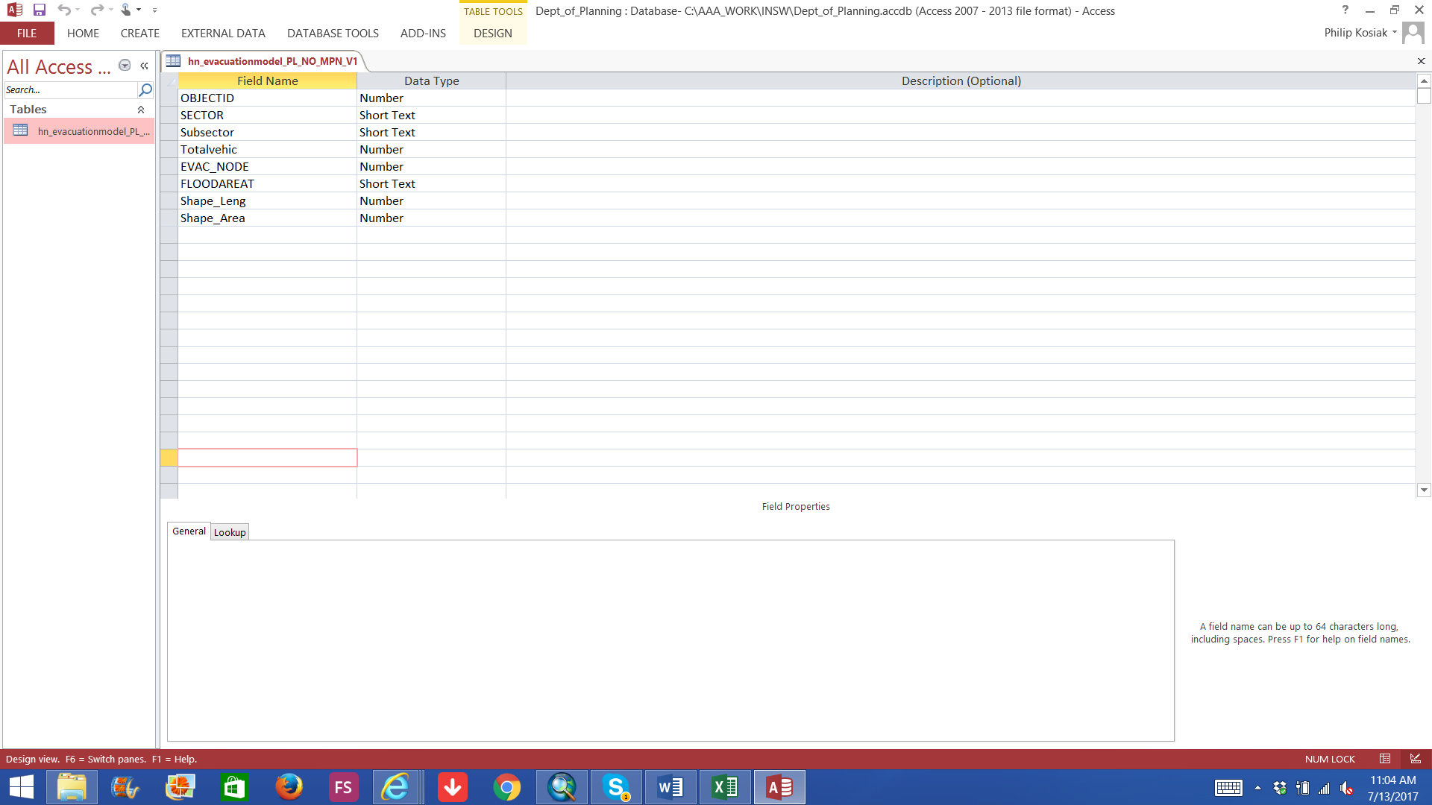

The following are mandatory fields:

**OBJECTID**: Unique subsector ID.

**SECTOR:** Sector name.

**Subsector:** Subsector name. As discussed sub sectors should match contours associated with each of the AEP’s being tested. In the Regional Model we look at 50, 100, 200, 500, 1000, 2000, >5000). Note each subsector must have a WMA reference point located within the subsector

**Totalvehic:** Total number of vehicles requiring evacuation from the subsector

**EVAC_NODE:** Node ID corresponds to a node on the network file where vehicles from this subsector will join the evacuation network. References ID field of the nodes shapefile.

**Road network shapefiles**

The EMME road network is defined by two shapefiles, links and nodes.

**Links**

Must have following description

**Shapefile: hn_net_ses_emme_Z_network_W_VX_links**

Where:

W is the road network option being tested

X is version Number

Z is development year (i.e. may be a different file for 2026 or 2041 depending on extent of roadworks)

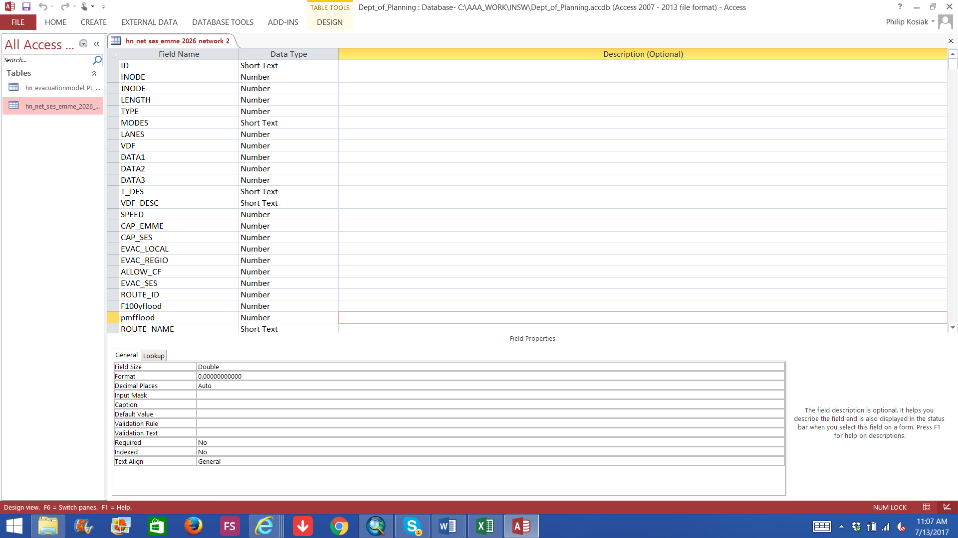

The following are mandatory fields:

**Field Type Description**

**ID:** string Unique ID for link.

**INODE:** Node ID of link tail. References ID field of the nodes shapefile.

**JNODE:** Node ID of link head. References ID field of the nodes shapefile.

**LENGTH:** Length (km) of link.

**LANES:** Number of lanes on the link.

**SPEED:** Maximum speed (km/h) along road.

**CAP_EMME** Capacity (vehicle/minute/lane) of the road.) 600 veh/he/ lane

**Nodes:**

Must have following description

**Shapefile: hn_net_ses_emme_Z_network_W_VX_nodes**

Where:

W is the road network option being tested

X is version Number

Z is development year (i.e. may be a different file for 2026 or 2041)

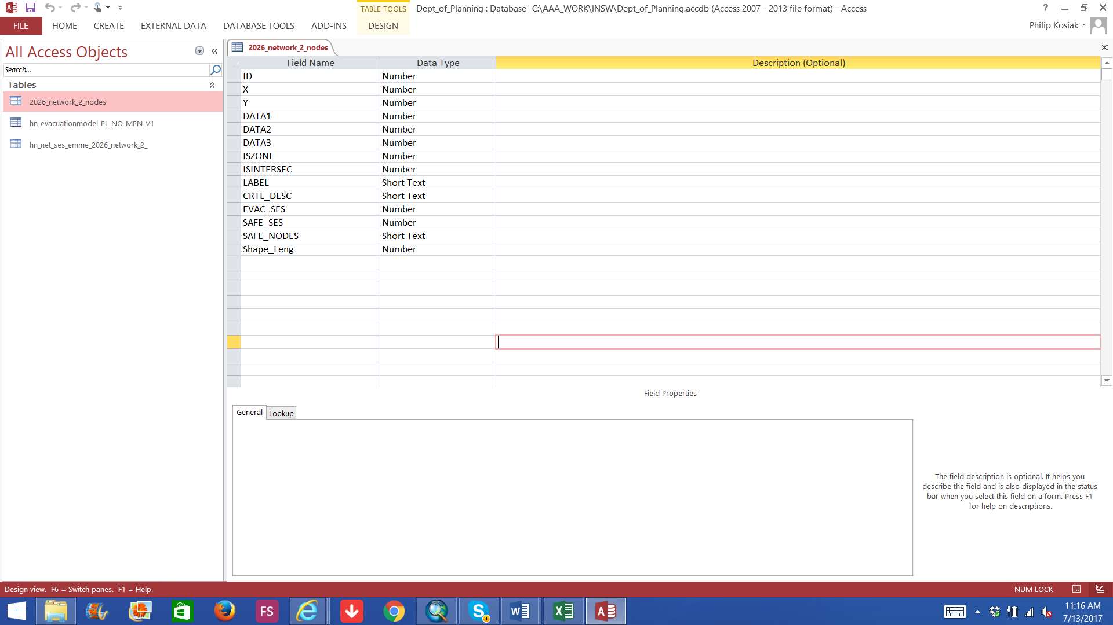

The following are mandatory fields:

**Field Type Description**

**ID:** Unique node id

**X:** (Easting) coordinate of node.

**Y:** (Northing) coordinate of node.

**SAFE_SES:** 1 if node is a safe node, 0 otherwise.

**SAFE_NODES:** Applicable to evacuation nodes only. A comma separated list of

safe node IDs. (e.g. “13082, 11119, 15136”) which vehicles from this node are allowed to evacuate to.

**EVAC_SES:** 1 if node is an evacuation node, 0 otherwise.

**WMA Reference points**

Defines the location and height of flood gauges, and which subsectors and roads they are

mapped to.

Must have following description

**Shapefile: wma_ref_points_1_to_2056_link_nodesV13_2041_4**

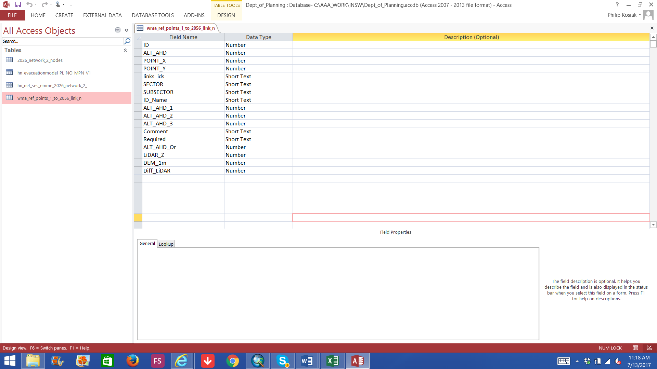

The following are mandatory fields:

**Field Type Description**

**ID:** Unique ID for the gauge. Referenced in flood event files.

**ALT_AHD:** Height of the gauge (m AHD) This correspondence to a level on the adjacent land (i.e. top of bank rather than invert of creel or river and reflects when flooding of adjacent land begins

**POINT_X:** (Easting) of the gauge.

**POINT_Y:** (Northing) of the gauge.

**links_ids:** string Comma separated list of link ids which the gauge is associated

with. Gauges associated with a link determine when that section of the road is cut.

**SECTOR:** Name of sector this gauge is within.

**SUBSECTOR:** Name of the subsector this gauge is within. Gauges within a subsector determine at what time it is flooded and hence the evacuation timeline.

**ALT_AHD_ {1,2,3}:** An alternative column which the simulation may be configured to

use instead of ALT_AHD for the gauge height. (this is used if in the future the level of the road may be raised